COMSATS UNIVERSITY ISLAMABAD,
ATTOCK CAMPUS



Submitted by:
M Abdullah Azam
Registration No:
Sp24-bse-034
Submitted to: Ms. Ambreen GUL
Subject: Information Security Lab

Note:
I added comments to the code of every task to explain.

TASK 01:
Answer:

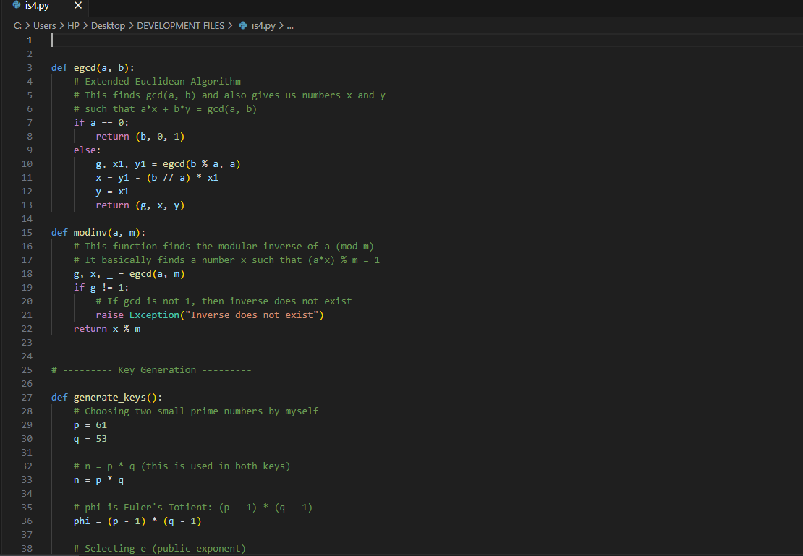

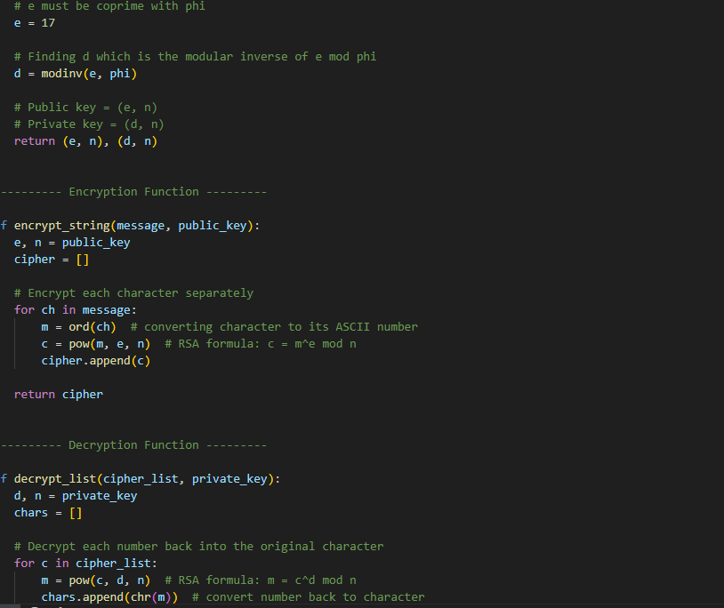

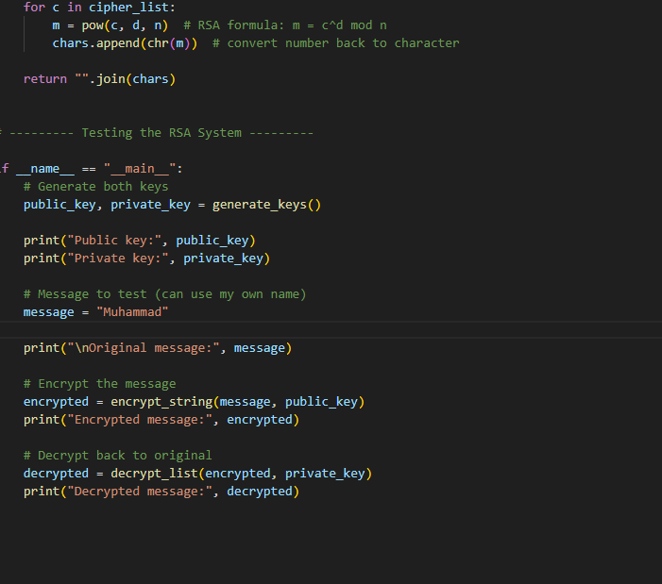

TASK 02:
Answer:

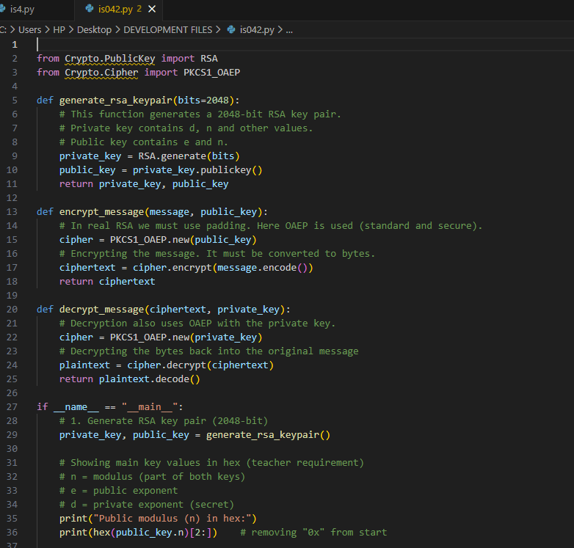

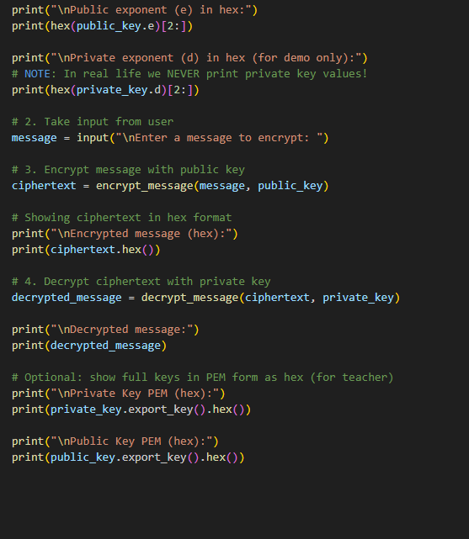

TASK 03:
Answer:
